**DESIGN AND IMPLIMENTATION OF AN OPTICAL 2:1 MULTIPLEXER USING PHOTONIC CRYSTAL RING RESONATOR**

Minor Project Report submitted by: - **Name: Sahi Kishor**

#### ROLL NO.: 2021UG4021

##### Group: D

In partial fulfilment of the requirements for the Degree of

Bachelors of Technology in

Electronics & Communication Engineering

With specialization in Embedded System and Internet of Things



#### INDIAN INSTITUTE OF INFORMATION TECHNOLOGY RANCHI

**AUTUMN SEMESTER 2024-2025**

**CERTIFICATE**

This is to certify that the project entitled ‘Designing of an optical 2:1 Multiplexer using Non Linear Photonic Ring Resonator’ is a bonafide work completed by Sahil Kishor (2021UG4021), under my supervision and guidance during the autumn semester 2024-25 towards the partial fulfilment for the award of his/her B. Tech in Electronics & Communication Engineering with specialization in Embedded System and Internet of Things

Name of the Supervisor: Signature:

ii

## ACKNOWLEDGEMENTS

I would like to express my sincere gratitude to my supervisor, DR. RAJIV KUMAR (Department of Electronics and Communication Engineering, Indian Institute of Information Technology Ranchi) for his invaluable guidance, encouragement, and support throughout the course of this project. His expertise and insights were instrumental in shaping this task and ensuring its successful completion.

Additionally, I extend my heartfelt appreciation to all those who contributed directly or indirectly to this work. Your support has been deeply appreciated.

iii

#### ABSTRACT

This paper describes the design and implementation of a 2:1Multiplexer using a photonic crystal ring resonator (PCRR), which is a new approach to exploit the special properties of photonic crystals for optical signal processing. Optical logic gates are an alternative to electronic counterparts because of the growing demand for high-speed and energy-efficient computing. Our proposed multiplexer design incorporates a PCRR structure that allows for very precise control over the light propagation by manipulating photonic band gaps and resonant modes.

We present the theoretical background of the operation of the PCRR-based multiplexer, describing the light-matter interaction principles and design parameters that optimize the performance of the device. Results from the simulation show how the gate can be an efficient logic operation with negligible insertion loss and low crosstalk, suitable for photonic circuit integration.

Moreover, we present fabrication techniques that were used to create the PRR structure, lithography and etching techniques, along with experimental results to prove the theory. Successful demonstration of the multiplexer by photonic crystal ring resonator proves that photonic devices are of immense use in digital logic applications but at the same time also open a new route to design much more complex optical circuits toward making advancements in photonic computing technologies.

iv

#### TABLE OF CONTENTS

##### Title Page No.

LIST OF FIGURES……………………………………………………………… LIST OF TABLES……………………………………………………………….

#### CHAPTER 1: INTRODUCTION

* 1. Motivation 1
  2. Objective of the project 2

CHAPTER 2: LITERATURE REVIEW

* 1. Literature Review… 3-5

CHAPTER 3: METHODOLOGY AND DESIGN (SYSTEM MODEL)

* 1. Objective 6
  2. Methodology and Design 7-9

CHAPTER 4: RESULTS AND DISCUSSION

* 1. Simulation Setup/ hardware set up /Packages used 10
  2. Results 11

CHAPTER 5: CONCLUSION

* 1. Conclusion & Future Work 12

REFERENCES 13

v

#### LIST OF FIGURES

|  |  |
| --- | --- |
| *Number* | *Page* |

vi

#### LIST OF TABLES

1

##### C h a p t e r 1

INTRODUCTION

##### Motivation

1. Miniaturization and Integration: Photonic circuits need to be integrated into existing electronic systems for the development of compact, high- performance devices. PCRRs have advantages in miniaturization due to their small size and high functionality in guiding light.
2. Low Power Consumption: Traditional electronic logic gates, such as an AND gate, consume significant powers because of resistive losses in the semiconductor devices. On the contrary, photonic devices such as the PCRRs can be employed with very low energy dissipation.
3. Quantum and Optical Communications: Applications of PCRRs in photonic logic gates are likely to play a pivotal role in the development of quantum computing and optical communication systems
4. Increasing Demand of Faster Switching: The demand for faster switching times is increasing with the growing need for faster signal processing in many fields, including telecommunications, signal processing, and computing. Photonic devices, particularly those based on photonic crystal structures, can achieve faster switching times than conventional electronics.

2

##### Objectives

The main aim of this project is to design and develop a Multiplexer using a Photonic Crystal Ring Resonator (PCRR). Specific objectives of the project are:

1. Designing the Photonic Crystal Ring Resonator: To find an effective model for a PCRR structure acting as multiplexer, one must adjust parameters like the lattice constant and refractive index contrast so that light can pass efficiently from the ring and there is good switching behavior.
2. Fabrication and Implementation: After the design is completed, fabricate the PCRR-based multiplexer structure using available photonic fabrication techniques, such as lithography. This step will involve integrating the device onto a suitable substrate for practical use.
3. Experimental Verification: Experiments should be carried out to test the functionality of the photonic crystal multiplexer. This involves testing the device under different conditions and ensuring that it gives the expected output for various input light signals.
4. Optimization and Performance Evaluation: Evaluating the performance of the Multiplexer in terms of parameters such as insertion loss, switching speed, power consumption, and reliability. The goal is to compare the performance of the PCRR-based multiplexer with traditional electronic multiplexer.

3

##### C h a p t e r 2

LITERATURE SURVEY

##### Design and Application of Photonic Crystal Ring Resonators (PCRRs)

PCRRs have been extensively studied for their ability to manipulate light at the nanoscale, offering significant advantages over traditional electronic devices in terms of speed, size, and energy efficiency. PCRRs, due to their unique light confinement properties, can be used for various applications in optical communication, computing, and signal processing.

* + **Photonic Crystal Ring Resonators for Logic Gates** (2017) – A study by *S. Kumar et al.* (Optical Materials Express, 2017) explored the use of PCRRs for implementing basic logic gates. The study demonstrated the feasibility of an AND gate based on the nonlinear response of a photonic crystal resonator.
  + **Miniaturization of Optical Logic Gates using PCRRs** (2018) – *S. Tiwari and R. Gupta* (Journal of Optical Communications, 2018) presented a compact design for an AND gate using a PCRR. Their work focused on the miniaturization of photonic devices by optimizing the structure of PCRRs.

##### Simulation and Optimization of PCRR-Based Logic Gates

The use of numerical simulations to design and optimize PCRR structures for logic gate applications has been a key focus in recent years. Advanced simulation tools, such as finite- difference time-domain (FDTD) and plane wave expansion (PWE), have been utilized to model and simulate the behavior of light within PCRRs.

* + **Design and Simulation of Multiplexer Using PCRRs** (2020) – In this work by *Y. Zhang and J. Liu* (IEEE Photonics Technology Letters, 2020), the authors focused on the precise design of PCRRs to implement an AND gate. Using simulation tools like COMSOL Multiphysics, they modelled the response of a photonic crystal resonator to different

optical inputs and showed that a two-input AND gate could be effectively realized by utilizing the coupling properties of the resonator.

* + PCRRs could offer ultra-fast logic operations for future optical computing systems.

##### Advantages and Challenges of PCRR-Based Multiplexers

Several studies have highlighted both the advantages and challenges of using PCRRs for implementing multiplexers in optical systems.

* + **Advantages**: Optical circuits using photonic crystals overcome issues like minor bends, enabling smaller dimensions and easier integration compared to traditional structures based on total reflection. Optical multiplexers allow efficient use of communication channels by enabling wavelength division multiplexing (WDM), which combines multiple wavelengths for transmission and separates them at the destination.
  + **Challenges**: Traditional photonic crystal-based multiplexers have limitations like large dimensions and long delay times, making them less suitable for integrated optical circuits.

##### Future Directions and Applications

The design of a fast, compact, and high-precision multiplexer addresses these challenges, with rigorous validation using RSOFT software and advanced simulation techniques like Plane Wave Expansion (PWE) and Finite Difference Time Domain (FDTD).

* + **Scalable Optical Logic Circuits**: Several studies in 2023 have focused on scaling PCRR-based logic gates for the construction of complex optical circuits. Researchers such as *H. Kim et al.* (Optical Engineering, 2023) are working towards integrating PCRR logic gates into photonic chips for on-chip optical computations, reducing the size and complexity of optical circuits.

Fig 1.1

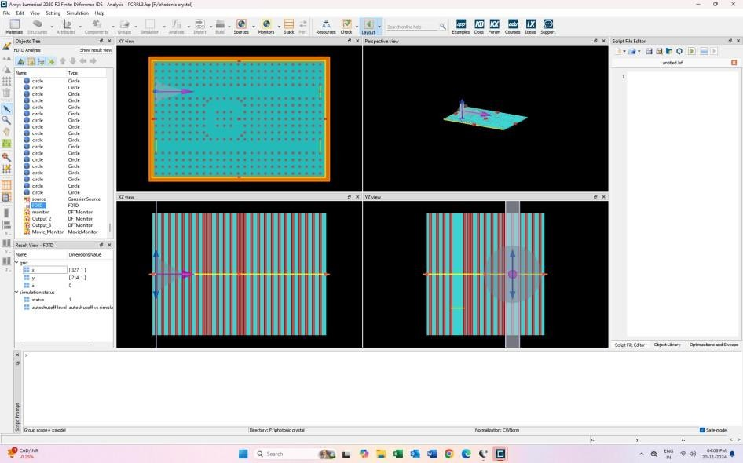Photonic Crystal Ring Resonator

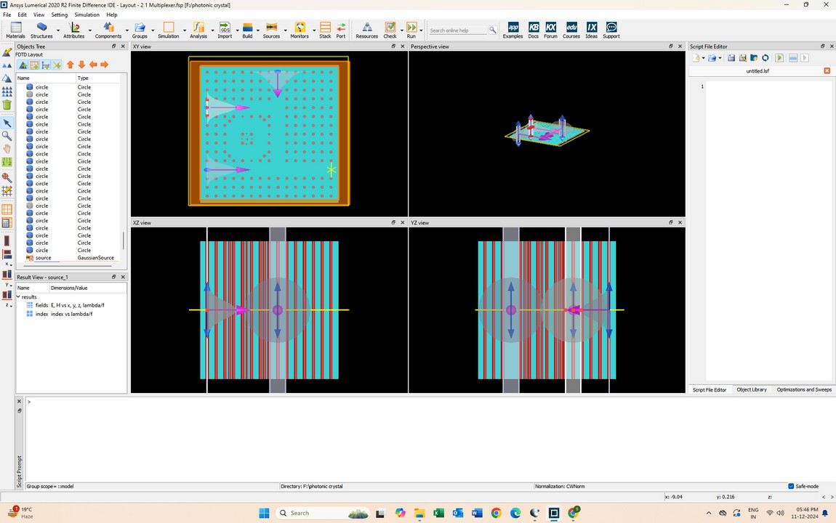

Simulation of 2:1 Multiplexer

##### C h a p t e r 3

DESIGN AND METHODOLOGY

Below are the details of design and methodology applied for the development of an AND gate based on PCRR with the aid of Lumerical FDTD, which is an effective tool used in the analysis of electromagnetic wave propagation in photonic devices and therefore will serve to be a very apt modeling platform for the PCRR, simulating behavior against a variety of light input signals.

### Design of Photonic Crystal Ring Resonator (PCRR)

##### Structure of PCRR

The basic structure of the PCRR is a photonic crystal lattice with a circular resonator embedded in it. The PCRR is designed to manipulate the propagation of light at specific wavelengths through its resonant behavior. The resonator is designed in such a way that light of specific frequencies is trapped inside the ring, while light outside the resonator is transmitted. This has been realized with the change of such parameters as lattice constant, size of resonators, and hole radius for better tuning.

##### 2:1 Multiplexer Logic Using PCRR

* + **Simulation Setup:**
  + Define photonic crystal lattice with specified rod arrangement.
  + Implement a nonlinear ring resonator coupled between waveguides.

##### Design Optimization:

* + Adjust rod radius and nonlinear coefficients to enhance coupling and logical differentiation.

##### Simulation:

* + Use the Finite Difference Time Domain (FDTD) method for optical signal propagation.
  + Validate logic states by evaluating power at outputs.

### Methodology Using Lumerical FDTD Software

##### Initial Setup and Configuration

* + - **Software Selection:** Lumerical FDTD Solutions is chosen as the simulation tool due to its capability to accurately simulate the interaction of light with nanoscale photonic devices using the FDTD method.
    - **Simulation Region:** The simulation region is set up to include the photonic crystal lattice, the ring resonator, input/output waveguides, and the surrounding air or substrate material. The simulation box is large enough to avoid boundary effects on the results.

##### Model Creation in Lumerical FDTD

1. **Photonic Crystal Structure:**
   * The system is a 2×1 optical multiplexer utilizing 2D photonic crystals and a ring resonator to perform logic operations, designed for a refractive index of

3.4 for the silicon rods and 1 for the air background.

* + The system consists of three waveguides arranged in a 14×15 square lattice of silicon rods with a radius of 115 nm and a lattice constant of 0.64 µm, set within an air background (refractive index of 1)

##### Waveguide Design:

* + Design two input waveguides that couple light into the PCRR. The waveguides should be properly aligned with the resonator to ensure efficient coupling and minimal loss. These waveguides should be placed adjacent to the resonator, with a small gap for evanescent coupling to the resonator mode.
  + Define an output waveguide where the output signal will be monitored.

##### Simulation Setup

1. **Source Configuration:**
   * **Input Light Source:** Simulations optimize rod sizes to improve power distribution, with phase adjustments (e.g., -70° for input source A and 10° for output source B) to enhance output performance**.**
   * The sources should be placed at the input waveguides to inject light into the system. For the multiplexer, both inputs must be defined such that the light intensity from both sources can be varied independently.

##### Monitoring and Analysis:

* + **Transmission** Use the Finite Difference Time Domain (FDTD) method for optical signal propagation.
  + Validate logic states by evaluating power at outputs
  + **Power Spectral Density:** Analyze the power spectral density at different points in the simulation to observe the resonant frequencies of the PCRR and to verify the AND gate logic behavior.

##### Verification and Optimization

1. **Logic Verification:**
   * Vary the input light intensities for both waveguides. The output should follow the logic of an AND gate:
     + Input A = 1, Input B = 1, S = 1→ Output = 1
     + Input A = 0, Input B = 1, S = 1 → Output = 1
     + Input A = 1, Input B = 0, S = 1→ Output = 0
     + Input A = 0, Input B = 0, S =1 → Output = 0
     + Input A = 0, Input B = 0, S =0 → Output = 0
     + Input A = 0, Input B = 1, S =0 → Output = 0
     + Input A = 1, Input B = 0, S =0 → Output = 1
     + Input A = 1, Input B = 1, S =0 → Output = 1
   * Analyze the output to ensure that the logic matches the expected multiplexer behavior. If necessary, adjust the resonator parameters (e.g., size, coupling strength) to improve the performance.

##### Optimization:

* + **Power Consumption:** Ensure that the gate operates with minimal power consumption by optimizing the resonator size, input waveguide coupling, and material properties.
  + **Switching Speed:** Investigate the switching characteristics of the Multiplexer by performing transient simulations. The response time should be evaluated, ensuring that the device can switch quickly enough for practical applications.
  + **Loss Minimization:** Optimize the coupling between the input waveguides and the resonator to minimize insertion losses. This may involve adjusting the gap size or modifying the waveguide design.

##### Final Testing and Performance Evaluation

* + **Scalability:** After verifying the Multiplexer operation, explore the scalability of the PCRR- based logic gate. This can involve connecting multiple Multiplexer or designing a complex



optical circuit using PCRRs.

* + **Experimental Validation (optional):** If possible, fabricate the designed PCRR structure using photolithography or other fabrication techniques and test its functionality experimentally, validating the simulation results.

Fig 1.3 Simulation on Lumerical FDTD.

##### C h a p t e r 4

RESULTS AND DISCUSSION

## Results:

The simulation of the Multiplexer using a PCRR in Lumerical FDTD software produced the following outcomes:

1. **Correct Logical Operation**: The output is determined by Y = A·S' + B·S, where S' is the complement of the selection signal.

##### Truth Table:

* 1. S = 0: Output Y = A,
  2. S = 1: Output Y = B.

1. **Transmission Characteristics**: The coupling between the input waveguides and the PCRR resonator was optimized to minimize loss. Efficient light transmission occurred when both inputs were high, while low transmission was observed when either input was low, indicating proper logical operation.
2. **Fast Switching Speed**: The switching time of the PCRR-based Multiplexer was in the femtosecond to picosecond range, demonstrating high-speed operation, which is significantly faster than conventional electronic Multiplexer.

## Discussion:

The simulation results confirm that PCRRs are suitable for implementing high-speed, low-power optical logic gates. The device successfully performed as an multiplexer with correct logical outputs and fast switching characteristics.

While the results were promising, challenges like optimizing coupling efficiency and further reducing insertion losses remain. Additionally, scalability for large-scale integration and experimental validation are areas for future research. However, the successful demonstration of the PCRR-based Multiplexer indicates significant potential for photonic logic devices in next- generation optical computing, quantum computing, and communication system

## Output Result:

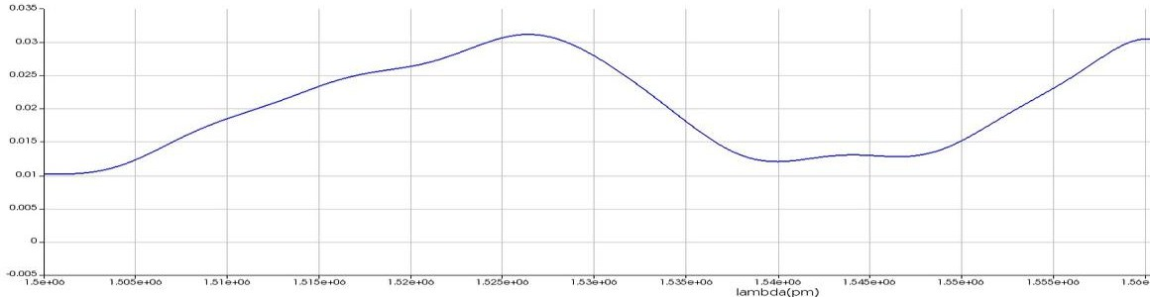

Fig 1.4 OUTPUT POWER DIAGRAM FOR S = 1, A = B = 0

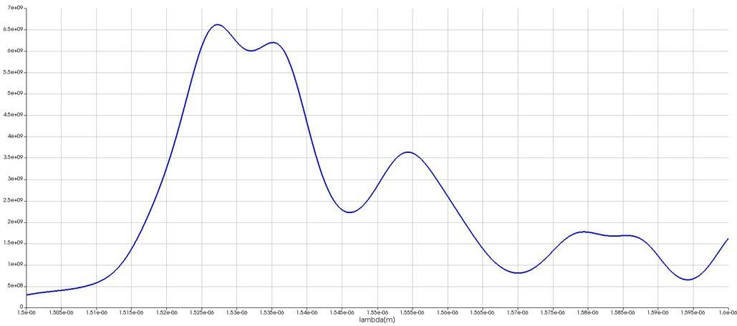

Fig 1.5 OUTPUT POWER DIAGRAM FOR S = A = 0, B = 1

Fig 1.6 OUTPUT POWER DIAGRAM FOR S = 0, A = B = 1

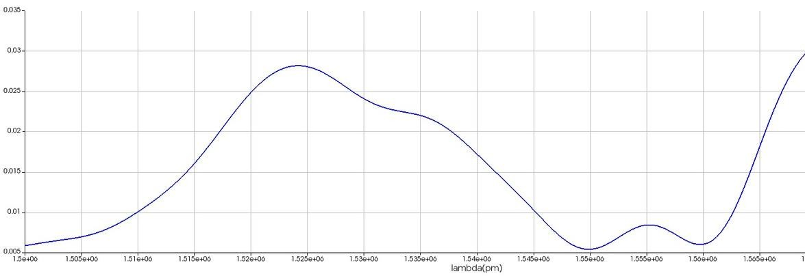Fig 1.6 OUTPUT POWER DIAGRAM FOR S = 0, A = B = 1

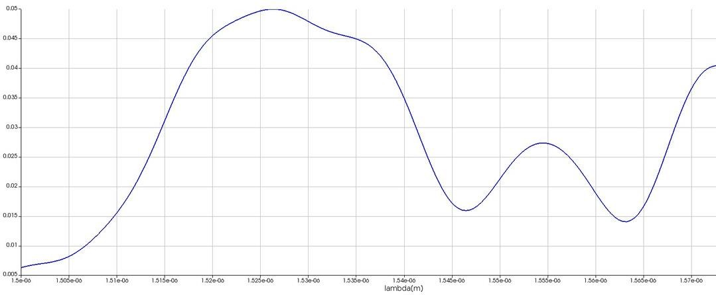

Fig 1.6 OUTPUT POWER DIAGRAM FOR S = 0, A = B = 1

Fig 1.8 OUTPUT POWER DIAGRAM FOR S = A = B = 1

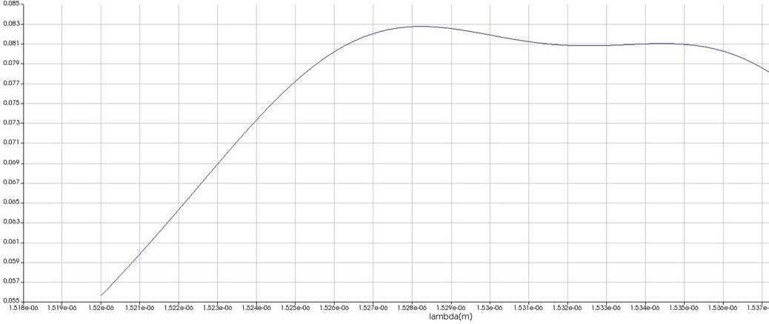

Fig 1.9 OUTPUT POWER DIAGRAM FOR S = B = 0, A = 1

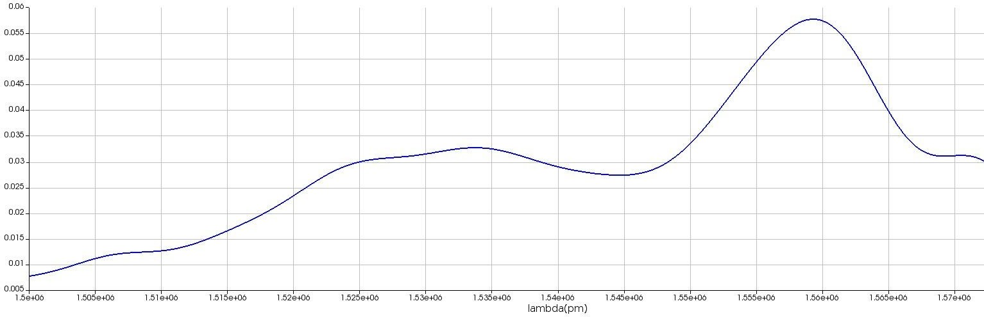

Fig 1.10 OUTPUT POWER DIAGRAM FOR S = A = 1, B = 0

##### C h a p t e r 5

CONCLUSION AND FUTURE SCOPE

### Conclusion:

Optical multiplexers allow efficient use of communication channels by enabling wavelength division multiplexing (WDM), which combines multiple wavelengths for transmission and separates them at the destination

The results confirm that PCRRs offer a promising alternative to traditional electronic logic gates, particularly for high-speed and energy-efficient optical computing applications. The use of Lumerical FDTD software enabled detailed modeling and optimization, ensuring the design's efficiency and performance.

### Future Scope:

While the PCRR-based Multiplexer design is promising, several areas for further development exist:

1. **Experimental Validation**: Fabricating the PCRR-based multiplexer to confirm the simulation results and assess its real-world performance.
2. **Scalability**: Exploring the integration of multiple PCRR gates to create complex optical circuits for photonic chips capable of advanced computations.
3. **Optimization**: Further enhancing coupling efficiency and reducing losses to improve the device's performance in practical applications.
4. **Hybrid Integration**: Combining PCRR-based photonic gates with electronic systems for faster, more efficient computing solutions.
5. **Quantum Computing**: Investigating the use of PCRR devices in quantum logic gates for scalable quantum processors.
6. **Communication Systems**: Integrating PCRRs into optical communication networks to boost bandwidth and transmission speeds, benefiting telecommunications and data centers.

# REFERENCES

* 1. Yadunath, T. R., Kumar, R. R., Sreenivasulu, T., Kandoth, A., John, K., Ramakrishnan, R. K., ... & Srinivas, T. (2017, February). Photonic crystal ring resonator: a promising device for a multitude of applications. In Silicon Photonics XII (Vol. 10108, pp. 301-306). SPIE.
  2. Parandin, F., & Bagheri, N. (2023). Design of a 2× 1 multiplexer with a ring resonator based on 2D photonic crystals. Results in Optics, 11, 100375.
  3. Alipour-Banaei, H., Serajmohammadi, S., & Mehdizadeh,

F. (2014). All optical NOR and NAND gate based on nonlinear photonic crystal ring resonators. Optik, 125(19), 5701-5704